Job Hazard Analysis

|  |  |
| --- | --- |
| Task/Equipment: | Servicing Supply and Exhaust Units in Chiller Room |
| Department: | Powerhouse |
| Analyzed By: | Bill Partin & Bryana Borders |
| Date: | 4/23/19 |

**Personal Protective Equipment Required:**



**Heavy Leather Gloves**



**Ear Protection**



**Hard Hat**

**Trainings Required*/Recommended:**

Ladder Training*, OSHA 10

**Equipment/Tools/Chemicals Required for the Job:**

Hand tool, garden hose, grease gun

|  |  |  |
| --- | --- | --- |
| Tasks/Steps | Hazards Present | Safety Measures and Controls |
| Climb enclosed ladder located in chiller room onto roof | Ladder fall | Enclosed ladder in place and follow ladder safety protocol |
| Open power disconnects to both exhaust and supply units and lock out | No hazards present | N/A |
| Remove covers from both exhaust and supply units and set aside | Finger cuts and abrasions | Use heavy leather gloves |
| Remove filters from filter bank of supply unit | Finger cuts and abrasions | Wear heavy leather gloves |
| tension drive belts on both units | Finger pinch | Wear heavy leather gloves |
| Grease motor and bearings and test for bearing wear | Finger pinch | Wear heavy leather gloves |
| Use a garden hose to wash filters and return to filter bank | No hazards present | N/A |
| Replace covers on both supply and return units and secure | Finger pinch | Wear heavy leather gloves |
| Remove lock out equipment and power up units and test operation | No hazards present | N/A |

**Additional Information:**

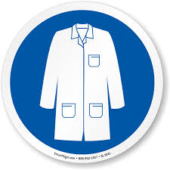

Lab Coat

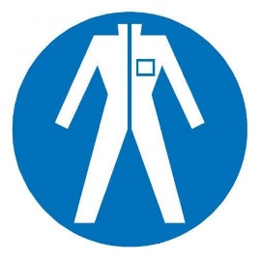

Protection Suit

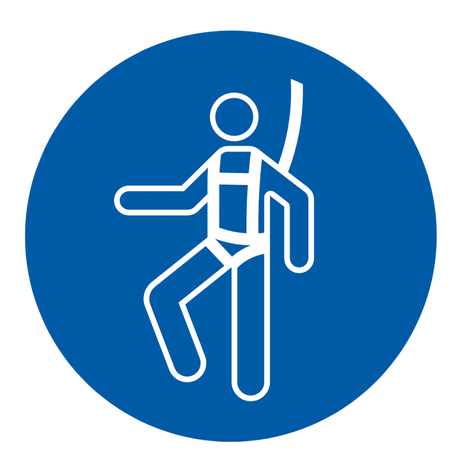

Fall Protection Harness



High Vis Vest

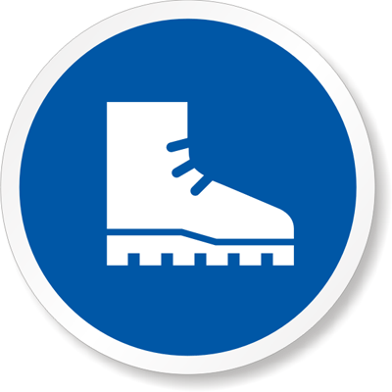

Safety Shoes



Splash Goggles



Cryogenic Gloves



Dust Mask

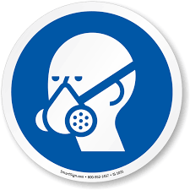

Respirator



Face Shield



Safety Glasses