Job Hazard Analysis

|  |  |
| --- | --- |
| Task/Equipment: | Removal of Burner, Summer Boiler |
| Department: | Powerhouse |
| Analyzed By: | Bill Partin & Bryana Borders |
| Date: | 4/12/19 |

**Personal Protective Equipment Required:**



**Heavy Leather Gloves**



**Hard Hat**

**Trainings Required*/Recommended:**

Proper ladder use*, **OSHA 10**

**Equipment/Tools/Chemicals Required for the Job:**

Hand wrench, washers, nuts, pipe wrench, screw driver, ladder and flash light

|  |  |  |
| --- | --- | --- |
| **Tasks/Steps** | **Hazards Present** | **Safety Measures and Controls** |
| 1. Open main power disconnects, and turn off control switch at burner panel. Secure using lockout tag out protocol | No hazards present | N/A |
| 1. Shut off main gas valves (2) and shut off pilot gas valve. Secure with lock-out tag-out protocol | No hazards present | N/A |
| 1. Attach chain fall to burner housing and support burner | Ladder fall | Proper ladder use |
| 1. Disconnect Gas line from burner at union | No hazards present | N/A |
| 1. Loosen and remove hex nuts holding burner to mounting flange | Finger pinch | Use heavy leather gloves |
| 1. Disconnect and remove gas pressure switch and store in a safe place | No hazards present | N/A |
| 1. Remove main flame and pilot scanner and secure | No hazards present | N/A |
| 1. Disconnect all pilot lines and set aside | No hazards present | N/A |
| 1. Remove all vent lines and set aside | Ladder fall | Proper ladder use |
| 1. Remove burner support stanchion and set aside | Falling objects | Stay clear and position an assistant to operate chain fall |
| 1. Remove gas recirculation piping and set aside | Ladder fall | Proper ladder use |
| 1. Remove burner muffler and set aside | No hazards present | N/A |
| 1. Move burner back from boiler along support-rail flame | Falling object | Stay from under burner at all times |
| 1. Inspect furnace and combustion chamber | Ladder fall | Proper ladder use |
| 1. Cordon off area with red caution tape | Falling objects | Stay clear |

**Additional Information:**

* This is a two person task

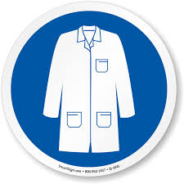

Lab Coat

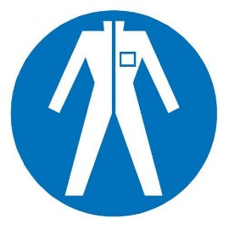

Protection Suit

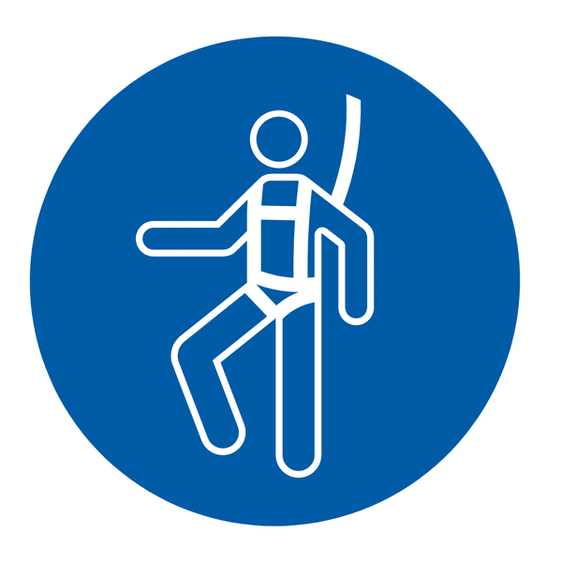

Fall Protection Harness

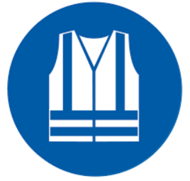

High Vis Vest

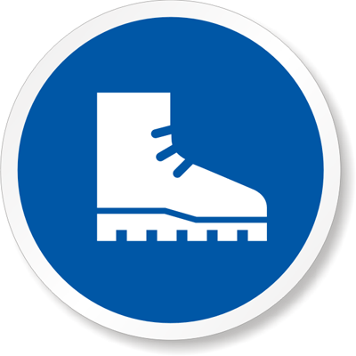

Safety Shoes

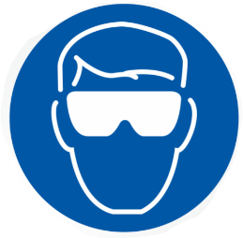

Splash Goggles



Cryogenic Gloves



Dust Mask

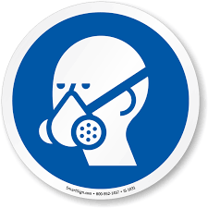

Respirator



Face Shield



Safety Glasses



Ear Protection