Job Hazard Analysis

|  |  |
| --- | --- |
| Task/Equipment: | Readying Summer Boiler For Inspection |
| Department: | Powerhouse |
| Analyzed By: | Bill Partin & Bryana Borders |
| Date: | 4/12/19 |

**Personal Protective Equipment Required:**



**Hard Hat**



**Heavy Leather Gloves**

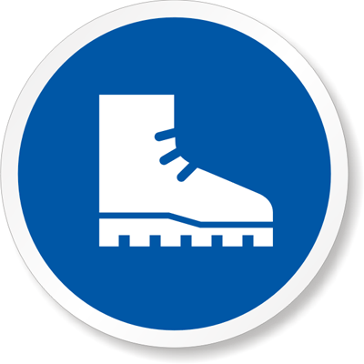

**Rubber Boots**

**Trainings Required*/Recommended:**

Ladder Training, Proper Chain Fall Use*, OSHA 10

**Equipment/Tools/Chemicals Required for the Job:**

Pipe wrenches, hand wrenches, hammer, ladder, gloves, chain fall

|  |  |  |
| --- | --- | --- |
| **Steps** | **Hazards Present** | **Safety Measures and Controls** |
| Turn off boiler at control panel | No hazards Present | N/A |
| Open 3 phase power disconnect and secure using lock-out protocol | No hazards present | N/A |
| Close and secure feed water stop valve at front of boiler and feed water isolation valves at side of boiler and tag | No hazards present | N/A |
| Close main gas valves (2) and secure using lock-out protocol | Potential | N/A |
| Allow boiler to cool and open drum vent | No hazards present | N/A |
| Close non return/stop on top of boiler | Ladder fall | Follow proper ladder protocol |
| Close surface blow down OS&Y valve and tag | No hazards present | N/A |
| After boiler cools ,open blowdown valve and drain boiler | No hazards present | N/A |
| Remove manway covers and discard old gaskets. | Finger pinch | Wear heavy leather gloves |
| Remove cross tees and inspection plugs | No hazards present | N/A |
| Rod out all steam and water line connected to safety controls | No hazards present | N/A |
| Remove water level safeties and move to side | No hazards present | N/A |
| Clean mud drum and remove any loose scale | No hazards present | N/A |
| Flush tubes with power hose if needed | Slip and fall hazard from a potentially wet floor | Wear rubber boots |
| Reclose blowdown valves and secure using lock-out protocol | No hazards present | N/A |

**Additional Information:**

* Two person task



Cryogenic Gloves

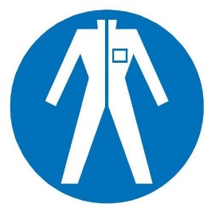

Protection Suit

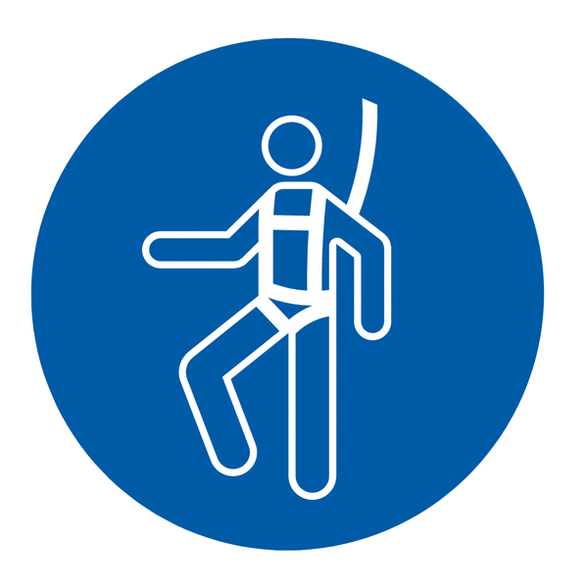

Fall Protection Harness

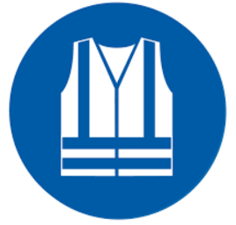

High Vis Vest



Splash Goggles



Dust Mask

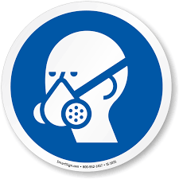

Respirator



Face Shield



Safety Glasses



Ear Protection