Job Hazard Analysis

**Personal Protective Equipment Required:**

|  |  |
| --- | --- |
| Task/Equipment: | Lubricating Tower Fan Bearing and Tensioning Fan Power Bands |
| Department: | Powerhouse |
| Analyzed By: | Bill Partin & Bryana Borders |
| Date: | 4/12/19 |



**Hard Hat**



**Light Leather Gloves**

**Trainings Required*/Recommended:**

Ladder Safety Training, Lock out tag out protocol*

**Equipment/Tools/Chemicals Required for the Job:**

Screw driver, tensioning wrench and grease gun

|  |  |  |
| --- | --- | --- |
| **Steps** | **Hazards Present** | **Safety Measures and Controls** |
| 1. Open disconnect at main control center MCC panel using lock-out tag-out protocol | Turning off wrong disconnect could cause serious injury in step 4 | Second person must verify that correct disconnect was opened and locked out |
| 1. Open main power disconnect mounted on tower structure and secure using lock-out tag-out protocol | Forgetting to open disconnect could cause serious injury in step 4 | Second person must verify that correct disconnect was opened and locked out |
| 1. Climb tower ladder and open access doors to fan compartment | Ladder fall | Ladder safety training |
| 1. Use tensioning wrench to adjust power band to desire tension | Hand loss or injury due to fans starting unexpectedly | Lock out and tag out fan power disconnects and post second person to insure that no one enables fans |
| 1. Attach grease gun hose to grease fittings and pump in grease | Ladder fall | Ladder safety training |
| 1. Close access door and secure | Ladder fall | Ladder safety training |

**Additional Information:**

-

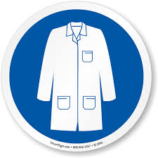

Lab Coat

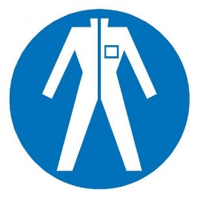

Protection Suit

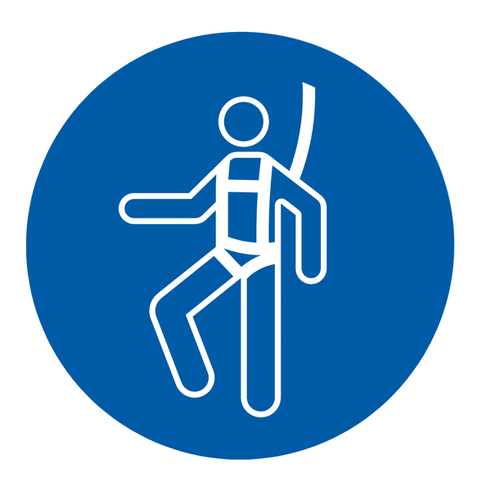

Fall Protection Harness

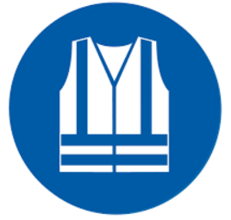

High Vis Vest

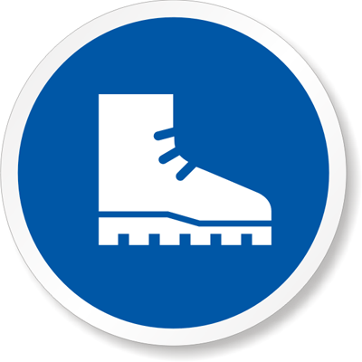

Safety Shoes

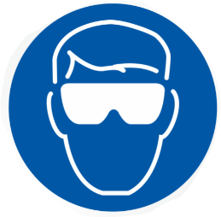

Splash Goggles



Cryogenic Gloves



Latex Gloves



Dust Mask

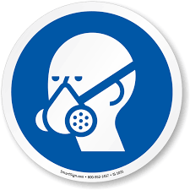

Respirator



Hard Hat



Face Shield



Safety Glasses



Ear Protection