Job Hazard Analysis

|  |  |
| --- | --- |
| Task/Equipment: | Filter/Separator Change on Control Air Compressors |
| Department: | Powerhouse |
| Analyzed By: | Bill Partin & Bryana Borders |
| Date: | 4/16/19 |

**Personal Protective Equipment Required**



**Hard Hat**



**Safety Glasses**



**Heavy Leather Gloves**

**Trainings Required*/Recommended:**

**Lock out tag out\***

**Equipment/Tools/Chemicals Required for the Job:**

Socket wrench, screw driver, filter wrenches, hand tools, funnel, oil/fluid absorbing compound; absorbent floor compound (optional)

|  |  |  |
| --- | --- | --- |
| **Steps** | **Hazards Present** | **Safety Measures and Controls** |
| 1. Start standby compressor | No hazards present | N/A |
| 1. check to insure water flow to drain from water-cooled standby compressor or cooling fan is running for air cooled compressor | Finger cuts and water splash-back into eyes | Wear leather gloves and eye protection |
| 1. Push stop button on control pad to stop compressor when being serviced | No hazards present | N/A |
| 1. Open main power disconnect at 3-phase distribution panel and secure using lock-out tag-out protocol | Skipping this step could cause major injury in step 6 + 7 | Lock-out tag-out procedure |
| 1. Isolate the compressor pneumatically and relieve system of air pressure until control panel pressure indicator reads zero | Skipping this step could cause serious face and eye injury in step 6 + 7 | Close and secure pneumatic pressure isolation valve using lock-out protocol .Verify that all system pressure has been dissipated before opening system to service. Wear safety googles and heavy leather gloves |
| 1. Open fluid filter drain valve to release fluid from filter rack | Eye or facial injury , skin burns from contact with hot fluid | Verify that all system pressure has been dissipated before opening system to service. Wear safety googles and heavy leather gloves |
| 1. Remove the filter/separator to be replaced using the filter wrench and hand tools | Eye or facial injury , skin burns from contact with hot fluid | Verify that all system pressure has been dissipated before opening system to service. Wear safety googles and heavy leather gloves |
| 1. Install new filter/separator and secure | No hazards present | N/A |
| 1. Close filter rack drain valve | Skin burns due to contact with hot surface | Wear heavy leather gloves |
| 1. Remove reservoir cap and visually check fluid level in sump. Add fluid if necessary | Skin burn due to contact with hot surfaces | Wear heavy leather gloves |
| 1. Replace reservoir cap and secure | Skin burns due to contact with hot surface | Wear heavy leather gloves |
| 1. Check for leaks around work area and filter/separator | Slip and fall | Mop up and clean any spills or fluid residue in work area. Apply absorbent floor compound to area if necessary |

**Additional Information:**

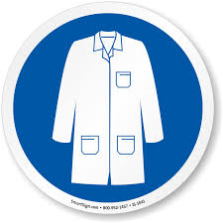

Lab Coat

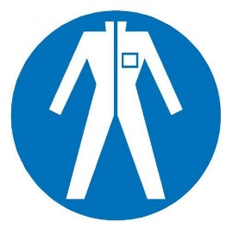

Protection Suit

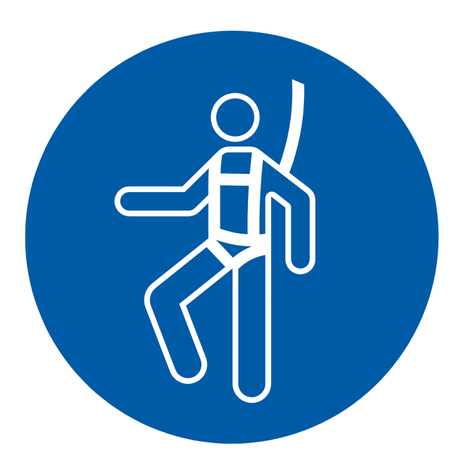

Fall Protection Harness



High Vis Vest

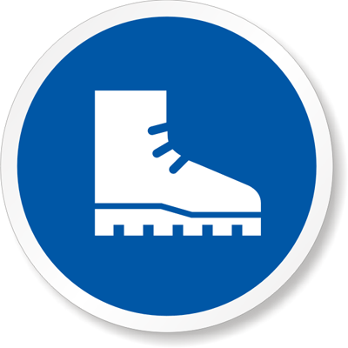

Safety Shoes

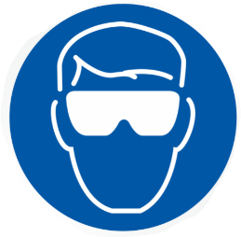

Splash Goggles



Cryogenic Gloves



Latex Gloves



Dust Mask

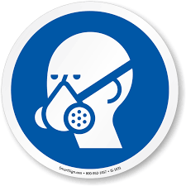

Respirator



Hard Hat



Face Shield



Safety Glasses



Ear Protection