Job Hazard Analysis

|  |  |
| --- | --- |
| Task/Equipment: | **Descaling** **Tower Nozzles** |
| Department: | Powerhouse |
| Analyzed By: | Bill Partin & Bryana Borders |
| Date: | 4/12/19 |

**Personal Protective Equipment Required:**

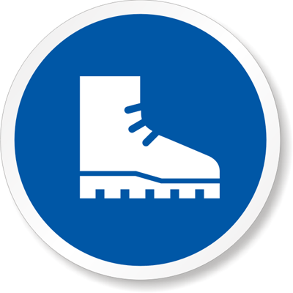

**Rubber Boots**

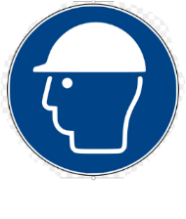

**Hard Hat**

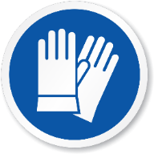

**Light Leather Gloves**

**Trainings Required*/Recommended:**

Ladder safety*, confined spaces training*, lock out tag out training*

**Equipment/Tools/Chemicals Required for the Job:**

Hand tools, screw driver, chipping tool

|  |  |  |
| --- | --- | --- |
| **Steps** | **Hazards Present** | **Safety Measures and Controls** |
| 1. Turn off tower controls at main control center MCC panel using lock out tag out protocol | If tower controls are not turned off and locked out/tagged out it could cause serious injury in steps 4-7 | Second person must verify correct disconnects are locked out and tagged out |
| 1. Open main power disconnects at tower and secure using lock out protocol | If power is not disconnected and locked out/tagged out, it may result in serious injury in steps 4-7 | Second person must verify correct disconnects are locked out and tagged out |
| 1. **Climb tower ladder, open entrance doors and enter tower confined space** | **Fall from ladder** | **Ladder Safety Training** |
| 1. **Remove upper horizontal tower fill to expose nozzles** | **Decapitation, severe head trauma due to fans starting unexpectedly** | **Lock out and tag out fan power disconnect, post second person to be sure no one enables tower fans , use confined spaces protocol** |
| 1. **Start condenser pumps to provide water flow** | **Decapitation, severe head trauma due to fans starting unexpectedly** | **Lock out and tag out fan power disconnect, post second person to be sure no one enables tower fans** |
| 1. **Use chipping tool to loosen and free scale from nozzles** | **Decapitation, severe head trauma due to fans starting unexpectedly; cuts from chipping tool** | **Lock out and tag out fan power disconnect, post second person to be sure no one enables tower fans; Use leather gloves to prevent cuts** |
| 1. **Replace upper fill** | **Decapitation, severe head trauma due to fans starting unexpectedly** | **Lock out and tag out fan power disconnect, post second person to be sure no one enables tower fans , use confined spaces protocol** |
| 1. **Exit confined space and close access doors and secure** | **Fall from ladder** | **Ladder Safety Training** |

**Additional Information:**

* Two-person Task

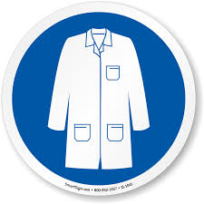

Lab Coat

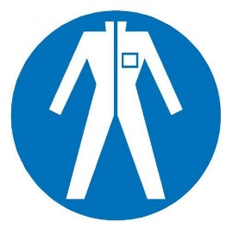

Protection Suit

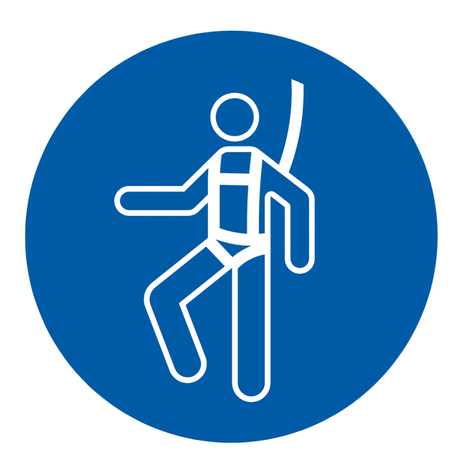

Fall Protection Harness

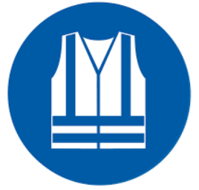

High Vis Vest

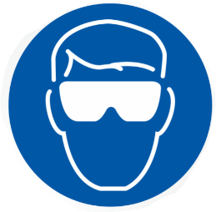

Splash Goggles

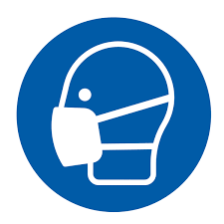

Dust Mask

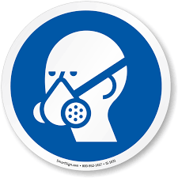

Respirator

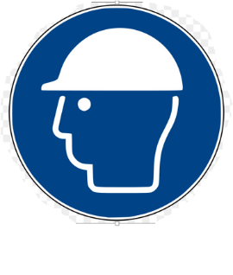

Hard Hat



Face Shield

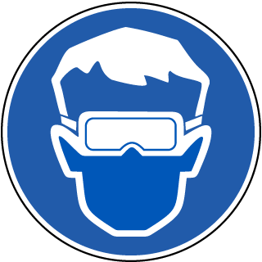

Safety Glasses



Ear Protection