Job Hazard Analysis

|  |  |
| --- | --- |
| Task/Equipment: | Reinstallation of Condenser Head on Chiller |
| Department: | Powerhouse |
| Analyzed By: | Bill Partin & Bryana Borders |
| Date: | 4/12/19 |

**Personal Protective Equipment Required:**

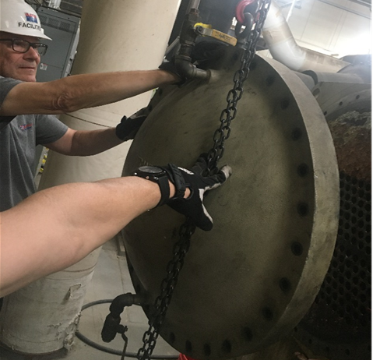



**Heavy Leather Gloves**

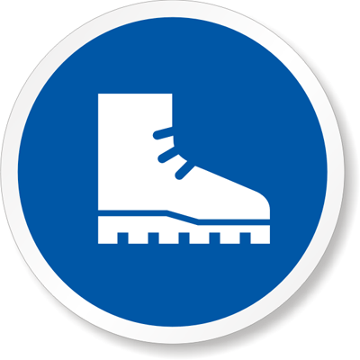

**Steel-Toe Boots**

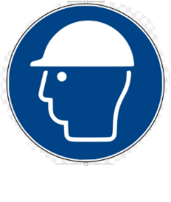

**Hard Hat**

Fig. 1

**Trainings Required*/Recommended:**

Proper use of chain fall* and hydraulic lift*

**Equipment/Tools/Chemicals Required for the Job:**

Rotary impact tool, chain fall, hydraulic lift

|  |  |  |
| --- | --- | --- |
| **Tasks/Steps** | **Hazards Present** | **Safety Measures and Controls** |
| 1. Attach chain fall to lift ring at top of head | Injury from swinging lift hook | Hold the lift hook while transporting or lowering or make sure the area is clear before transporting |
| 1. Clean O-ring groove with a clean cloth | No hazards present | N/A |
| 1. Apply a thin coat of grease to O-ring and place into groove on head | No hazards present | N/A |
| 1. Raise head to condenser level using lifting device | Heavy condenser head could fall on someone’s foot and cause serious injury | Wear steel-toe boots. Also make sure the lift hook is attached to the O-ring and is secured. |
| 1. Position one person to guide head into place while the other operates the lift device | Fingers/ hands get pinched. Can cause severe injury | Be sure to steer the condenser head by placing both hands on the center part of the head away from the rim. Do not grab or put your hands on or near the rim of the head (see Fig. 1 on the previous page)**.** |
| 1. Reinstall bolts around the perimeter of the head and secure | Wrist twist | Careful use of impact tool. Use heavy leather gloves for grip |
| 1. Unhook lifting device and move to a safe location for storage | Potential for the lift hook to swing out and hit someone | Move the lift device carefully and store away from walkways/traffic areas/ |

**Additional Information:**

* This is a two person task



Safety Shoes



Latex Gloves

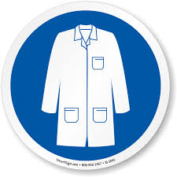

Lab Coat

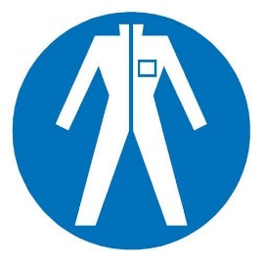

Protection Suit

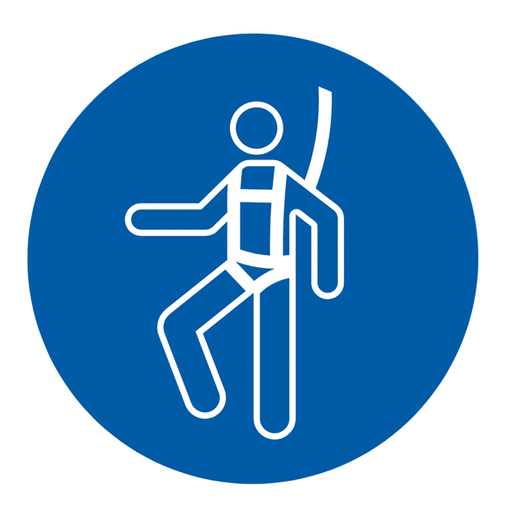

Fall Protection Harness

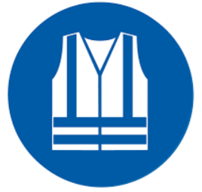

High Vis Vest

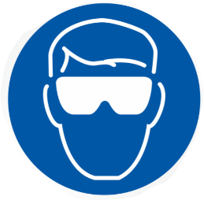

Splash Goggles



Cryogenic Gloves

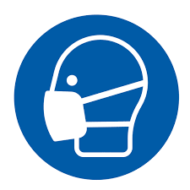

Dust Mask

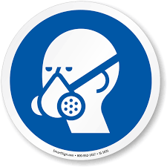

Respirator



Face Shield

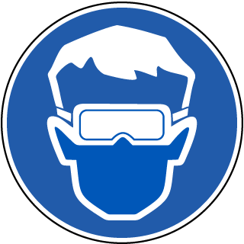

Safety Glasses



Ear Protection