Job Hazard Analysis

|  |  |
| --- | --- |
| Task/Equipment: | Readying Winter Boiler for Annual Inspection |
| Department: | Powerhouse |
| Analyzed By: | Bryana Borders & Bill Partin |
| Date: | 4/12/19 |

**Personal Protective Equipment Required:**



**Hard Hat**



**Heavy Leather Gloves**

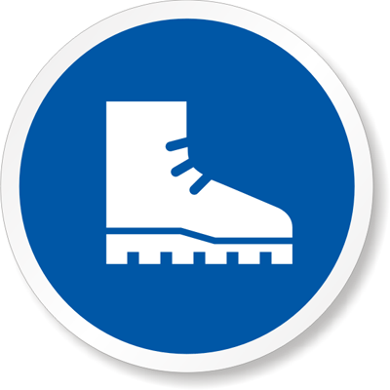

**Rubber boots**

**Trainings Required*/Recommended:**

Proper ladder use*, proper chain fall use*

**Equipment/Tools/Chemicals Required for the Job:**

Rotary Impact Tool

|  |  |  |
| --- | --- | --- |
| **Steps** | **Hazards Present** | **Safety Measures and Controls** |
| 1. Turn off boiler at panel | No hazards present | N/A |
| 1. Close and secure feed water globe valve and tag as closed | No hazards present | N/A |
| 1. Open main power disconnect and place lock-out device on handle | No hazards present | N/A |
| 1. Close main boiler gas cock and leave handle in the horizontal position | No hazards present | N/A |
| 1. Allow boiler to cool until pressure falls to 3 psi, then climb onto the boiler and open up steam drum vent | Ladder fall | Follow ladder safety protocol |
| 1. Close non-return and OY&Y stop valves on top of boiler | No hazards present | N/A |
| 1. Disable chemical feed pump if applicable | No hazards present | N/A |
| 1. Close surface blowdown stop valve closest to boiler and tag as closed | No hazards present | N/A |
| 1. Allow boiler to further cool until water temperature falls below 100 °F | No hazards present | N/A |
| 1. Open bottom blowdown valves and drain the boiler completely | No hazards present | N/A |
| 1. Remove manway covers and discard old gaskets | Finger pinch | Wear heavy leather gloves |
| 1. Remove all cross-tees and inspection plugs | No hazards present | N/A |
| 1. Rod out all water and steam piping associated with plus and tees, pressure and level safeties | No hazards present | N/A |
| 1. Remove water level safety float and place to the side | No hazards present | N/A |
| 1. Clean and remove any loose scale or debris in the mud drum | No hazards present | N/A |
| 1. Flush tubes wit power hose if needed | Wet floor can cause a slip and fall accident | Wear rubber boots |
| 1. Reclose bottom blowdown valves and attach a lock-out device over valves | No hazards present | N/A |
| 1. Open fire-side access door and visually inspect furnace refractory and tubes | No hazards present | N/A |
| 1. Contact city of Detroit boiler inspector for inspection appointment | No hazards present | N/A |

**Additional Information:**



Ear Protection

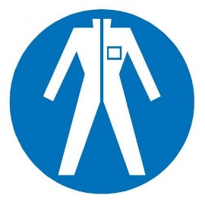

Protection Suit

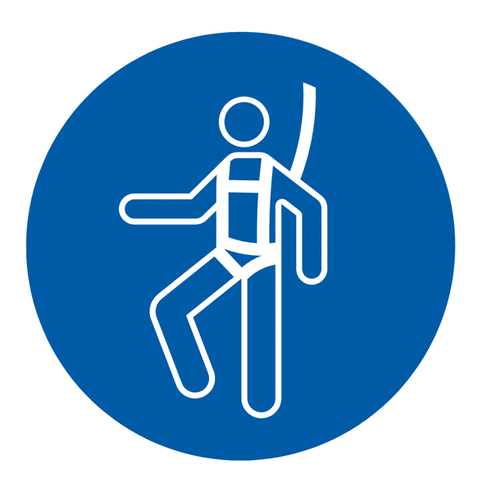

Fall Protection Harness



High Vis Vest



Splash Goggles



Latex Gloves



Dust Mask

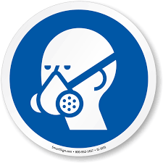

Respirator



Face Shield



Safety Glasses