Job Hazard Analysis

**Personal Protective Equipment Required:**

|  |  |
| --- | --- |
| Task/Equipment: | Disposal of Empty Chemical Containers |
| Department: | Powerhouse |
| Analyzed By: | Bill Partin & Bryana Borders |
| Date: | 8/12/19 |



Water proof Slip Resistant



Face Shield



Leather Gloves Gloves



Chemical Resistant Gloves



Face Shield

**Trainings Required*/Recommended:**

Hazardous Communication

**Equipment/Tools/Chemicals Required for the Job:**

Reciprocating saw , garden hose

|  |  |  |
| --- | --- | --- |
| Tasks/Steps | Hazards Present | Safety Measures and Controls |
| Triple rinse containers to drain | Slip and fall, chemical back splash to face, eyes and skin | Wear waterproof boots, wear face shield and chemical resistant gloves. Rinse off in the emergency safety shower if |
| Cut up containers using a reciprocating saw and throw into dumpster | Cuts ,foreign objects in eyes | Leather gloves and face shield |

**Additional Information:**

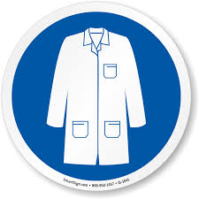

Lab Coat

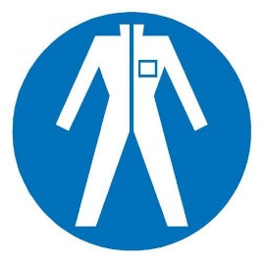

Protection Suit

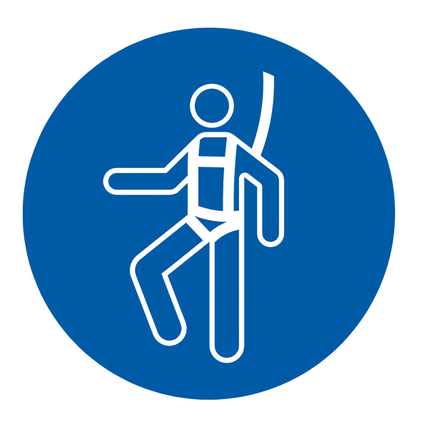

Fall Protection Harness



High Vis Vest



Splash Goggles



Cryogenic Gloves



Latex Gloves



Dust Mask

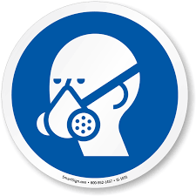

Respirator



Hard Hat



Face Shield



Safety Glasses



Ear Protection