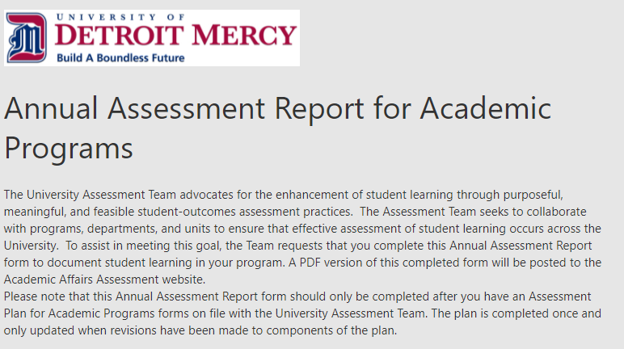

- Degree Level and Program Name (e.g. BA History, MS Physician Assistant, JD Law, DDS Doctor of Dental Surgery):

- College/School

- Assessment Overview
Briefly share how student learning outcomes assessment is conducted within your program/department (e.g. number of outcomes, examples of assignments used, and frequency of assessment). See example in #8 below. Limit is 100 words.

- Student Learning Outcomes
Which student learning outcome(s) from the assessment plan are being reported on in this report? Include the corresponding benchmark(s) for each outcome. See example in #9 below.

- For which institutional outcome(s) do the reported student learning outcome(s) align?

- Assessment Period: Select the academic year for which you are reporting results (e.g. when data were collected):
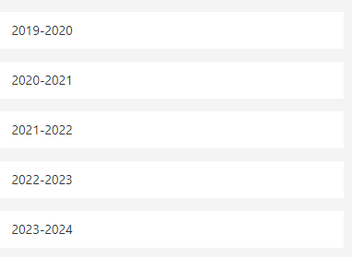

- Results, Planned Actions, and/or Actions Taken
Briefly summarize the assessment results, how they relate to benchmark(s), and how you are using them to enhance student learning and improve program quality. See example in #10 below. Limit is 100 words.

EXAMPLES TO RESPONSES

- Example: Assessment Overview
The BA Economics program has three student learning outcomes, with one outcome assessed each year. Faculty assess student learning outcomes using direct measures from embedded assignments (e.g. exams, quizzes, and projects using rubrics).

- Example: Student Learning Outcomes
Referencing the BA in Economics Program Assessment Plan on file with the University Assessment Team, one outcome is being assessed in this cycle. Student Learning Outcome #2: Express Qualitative and Quantitative Tools of Analysis - Students will demonstrate a familiarity with qualitative and quantitative analysis in explaining economic theories that underlie social and economic problems. The benchmark for success is to have all students earn a rubric equivalent score of a C or better on the research project in ECN 4355.

