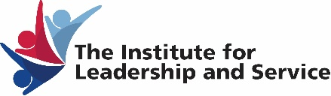
Ford Community corps partnerships at udm 2019-2020
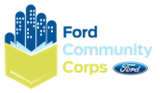
Proposal evaluation rubric
CRITERIA | DETAILS
1. Quality of Community Engagement | How critical (to the well-being of our city and region) are the issues which the students will encounter in the process of this project?  - e.g. Engagement with the issue of foreclosures would rate higher than engagement around the question of preparedness for a tsunami.  - Quality of classroom students’ engagement through a community engagement events/activities. For a project to be considered strong in this area, it would have to include at least six events that engage persons in the community.  - Quality of interaction between the classroom students and service recipients.  - Will the students get to know the service recipients and vice versa? How well?  - What are the chances that some quality relationship can form?  - How likely does it seem that the project will make a positive impact from the perspective of those being served?
2. Quality of Service-Learning Engagement | How well will the course engender the values of the Social Change Model (SCM), or bring about some "transformative" experience for the classroom students leading to enhanced leadership and service?  - How likely does it seem that the course assignments will help the classroom students to engage in reflection and integrate the values of the SCM?  - How likely does it seem that the experience of the students while doing the project will enhance their classroom learning?  - Minimum of 7 student participants per community engagement event
3. Value added - How well does the proposal indicated the need for/use of the fund. | How great is the potential for the student leader to develop leadership skills in the context of this project?  How critical is the student leader's help to the faculty member?  How many students will participate in this project?
4. Quality of Project Planning | How well have the faculty/student leader thought through the project and foreseen some of the important organizational needs and addressed them?  How well have the faculty/student leaders assessed the needs and assets of those who be served by this project?  What is the potential to positively impact that area of need?
5. Additional consideration will be given to | Student Initiative: We place value on projects that the student leaders initiate  Value to Detroit Mercy (e.g. working in the neighborhood around the campus)  Quality of Outcomes Assessment of the impact on service recipients or the assessment of the SL outcomes.  Potential for Student Leader to Impact Student in SL Class: What is the student leader’s previous community engagement and leadership experience.

